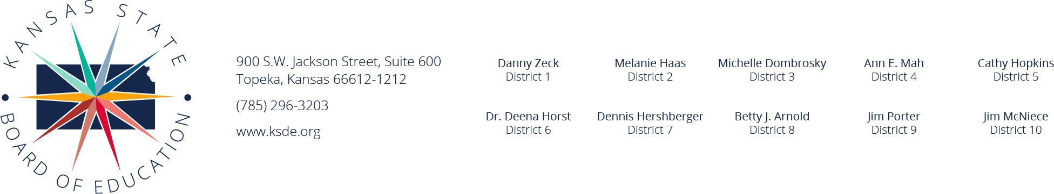  Minutes  Blue Ribbon Task Force on Student Screen Time November 7, 2024  The twelfth meeting of the Blue Ribbon Task Force on Student Screen Time began at 4:00 p.m. on November 7, 2024. The meeting was virtual.  Co-Chairs: Principal Brian Houghton and Student Ava Gustin  Statement of Purpose  Develop guidance/recommendations, based in research, on:  - students’ personal device use in school,  - screen time and mental health, and  - parental oversight of district-owned devices.  Calendar for meetings  November 12 at 10:55 a.m.: Report presented to State Board of Education by Co-Chairs  Welcome from Commissioner Watson  Dr. Watson welcomed the members of the Task Force.  Payton Lynn, KSDE staff, explained why some comments from the Task Force were not included. She then went through the final report and explained all the sections.  Lane Lamping moved the Blue Ribbon Task Force on Student Screen Time adopt this report as an accurate representation of the task force’s work to be presented to the Kansas State of Education. Lyndsey Noble seconded the motion. Motion carried. (need the actual number)  Katie Allen moves that the Blue Ribbon Task Force on Student Screen Time relevant research citations that address the connection of academic performance and personal device use be added. Kim Whitman seconded the motion. Motion carried. (need the actual number)  Commissioner Watson explained the process from this point. The report will be sent tomorrow to the State Board members. The Co-Chairs will present, with the KSDE staff, and the board will receive the item and then vote on it in December. What the board approves will be disseminated to schools across Kansas as recommendations, not mandates. He thanked everyone, especially the Co-chairs who did such an excellent job. Brian Houghton echoed that sentiment and thanked the staff, and all the members of the task force. Ava Gustin added her gratitude and especially thanked the other students who participated on the Task Force.  The meeting and the Blue Ribbon Task Force on Student Screen Time was adjourned. | Motions  23:13

